
E-SAFETY at Chapel Allerton Primary School
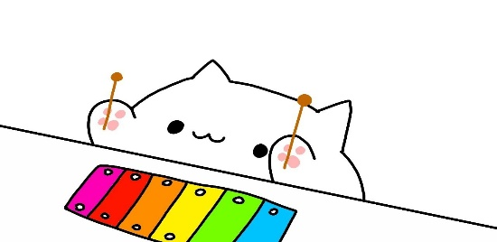
Created by your local, friendly School Councillors!

IMPORTANT ALERT!!!!!!
This is for children to read instead of that great big long and boring one for adults.

There are lots of fun and interesting things you can do on the internet.
You can learn lots of things.
You can have lots of fun.
It can help with our schoolwork.
And it can be a great way to stay in touch with friends.
But it’s important to understand how to stay safe online because you must stay safe.

What is E-Safety?
E-Safety means electronic safety.
E-Safety is important because it helps to keep children safe so they can enjoy, explore and have fun!

Why we need an E-SAFETY policy:
- To keep us safe on the internet at school and at home.
- So we don’t get hurt or bullied online.
- To make sure that we know what to do if we are upset or worried by something we see online
- Some apps, games, and websites are NOT safe.
- The e-safety policy can protect you from STRANGER DANGER!
What our school does to respond to E- SAFTY issues.
- Every class at CAPS does E- SAFTEY lessons every year in computing to teach us about being safe online.
- They restrict the websites we use on CAPS’S computers and i-pads to prevent us from seeing unsafe things online.
- Our school keeps nasty computer viruses away.
- Our school makes sure that all the staff have all the right training to keep us safe on the internet.

Some words you might hear and what they mean
Cyber bullying:
Cyber bullying is a form of bullying. It is where someone is being mean online. If this ever happens you should tell an adult.


SCAMS…😱😨
A scam is when someone is asking for your personal details. They can trick you and if you give them that information, they can do lots of bad things with that information. People who have certain information about you can take your identity. This is called identity theft. The next time people ask you for your information, be careful who you give it to!




Invasion of privacy
Invasion of privacy means when you tell someone a secret or and that person would tell everyone. You would feel betrayed and upset so be CAREFUL ON THE INTERNET. Be AWARE if any of these things happen to you, and if they do, tell a trusted adult or friend.

What should I ALWAYS do?
Think about who you’re talking to:
There are lots of ways that people try to trick you into trusting them online. Even if you like and trust someone you’ve met online, never share personal information with them like your address, full name, or where you go to school
Tell someone if you are worried- your grown-ups, your teacher or your family they can and will help you.
Be kind, ALWAYS be kind.

Do not be unkind or nasty

What should I NEVER do?
- Don’t ever, ever share personal information about yourself- like your name or school or where you live
- Never Be mean or unkind
- DON’T go on unsafe apps or websites that aren’t suitable for your age, always check
- Never TELL anyone WHAT YOUR PASSWORD IS

Our Internet Rules
We use websites our Teachers have advised us to look at- the safe ones.
We only e-mail people our Teachers have asked us to.
When we send e-mails or messages they are polite and friendly.
We never give out our address or telephone numbers.
We never arrange to meet anyone we don’t know.
We don’t open e-mails from people we don’t know..
We tell a teacher if we see anything that we are unhappy with.

How should we act on the Internet?
-S –Keep your personal information SAFE and SECURE
-M –Do not agree to meet anyone from the Internet; they may not be who you think they are
-A –Do not ACCEPT messages or e-mails from somebody you don’t know.
-R –Remember, do not always trust the information you find on the Internet; it may not be correct.
-T –If something or someone upsets you on the Internet TELL a trusted adult in school or at home.



MAKE SURE YOU READ ALL OF THIS INFORMATION, BECAUSE IT MIGHT COME IN HANDY SOME DAY! ❤

